Advertising Campaign Proposal – Google Display Network (GDN)
Hamleys - Website traffic campaign - 10 Dec 2025
Product: Toyspree Rally Racer for Kids
Brand: Hamleys India
Budget: ₹30,000 / 1 Month
1. Competitor Analysis
Key Competitors of Hamleys in the Indian Market
- Hamleys
  - Premium international toy retailer known for experiential stores.
Top 3 Competitors
1. Toys“R”Us India
- Large global toy retailer with expanding India presence.
- Strong appeal through branded toy collections and value-driven promotions.
2. LEGO (Official Stores & Online Marketplace Sellers)
- High brand trust and strong product quality.
- Appeals to both kids and parents with educational and creative play sets.
3. FirstCry
- India’s largest online kids’ store with toys, baby products & accessories.
- Competitive pricing, heavy discounts, and mass reach across India.
2. Unique Selling Propositions (USPs) of Hamleys
1. Premium & Trusted Global Toy Brand
Hamleys has over 260 years of heritage, making it one of the most reliable and recognized toy retailers worldwide.
2. Curated, High-Quality, and Safe Toys
Every product follows strict international safety standards ensuring safe play for kids.
3. Experiential Retail + Exclusive Collections
Hamleys stores are known for interactive experiences, and its exclusive toy collections offer differentiation from mass-market competitors.
4. Strong Parent Trust & Brand Recall
Parents perceive Hamleys as a premium gifting destination—enhancing purchase confidence.
5. Limited-Edition & Innovative Toys
Products like the Toyspree Rally Racer offer uniqueness not easily available through general retailers.
3. Campaign Objective
Selected Objective: Website Traffic
Reason:
The primary goal of the advertising campaign is to increase visitors to the Hamleys India official website, specifically the product page for the Toyspree Rally Racer. GDN (Google Display Network) is ideal for awareness + website visitation, as it allows us to:
- Reach parents, gift-buyers, and toy-interested audiences across millions of websites and apps
- Use compelling visual banners to attract attention
- Drive targeted users directly to the product landing page
- Increase top-of-funnel traffic that may convert into sales
- Retarget warm audiences for higher purchase probability
Why Website Traffic > Sales Objective?
- Budget is limited (₹30,000), making website traffic more efficient for maximizing reach.
- Product-specific brand awareness needs to be built first.
- Display ads are best suited for traffic generation, not final conversions.
- Once traffic is generated, retargeting can later push for sales.
Outcome Expected:
- Increase in page visits for Toyspree Rally Racer.
- Higher engagement among parents and kids’ product shoppers.
- Strong remarketing pool for future conversion campaigns.
Objective selection screen.
Budget, dates and ad schedule (if you applied)
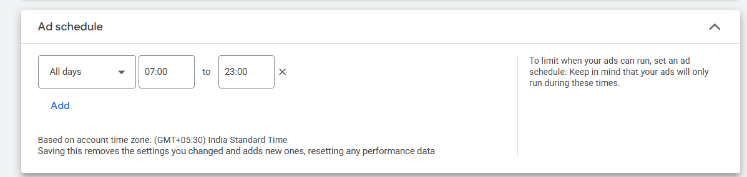
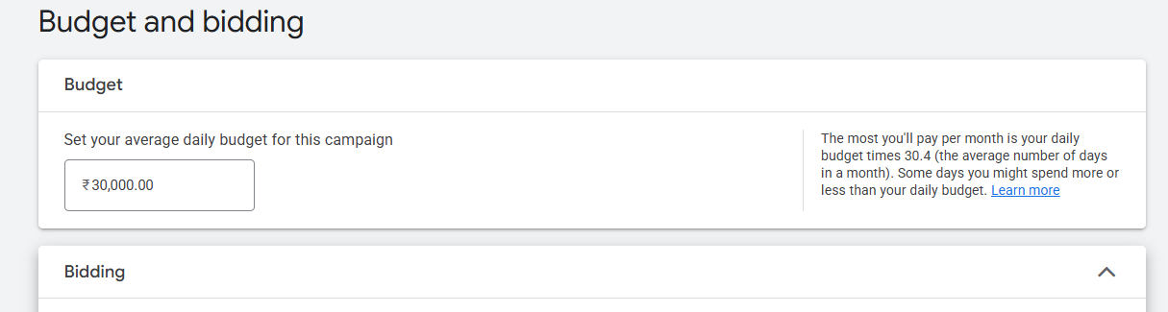
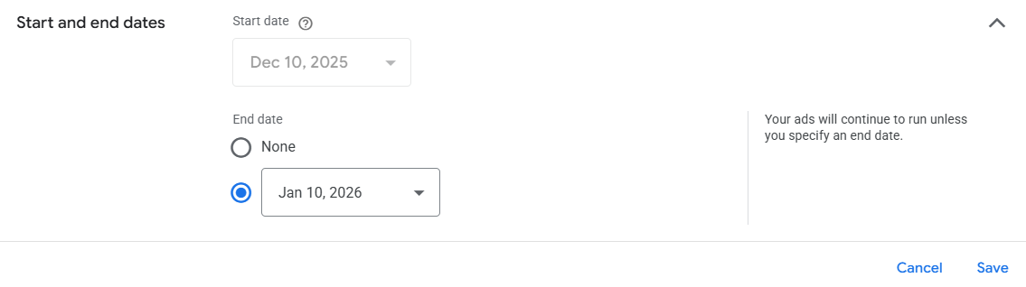
List of keywords research for the campaign, with their search volume and competition. (If your applied)
Keyword | Search Volume | Competition
shop toys | 50000 | High
toy toys | 5000 | High
kid toy | 500 | High
child toy | 500 | High
games toys | 500 | Medium
fun toy | 500 | Medium
best toy | 5000 | High
girl toys | 5000 | High
children toy | 50000 | High
childhood toys | 500 | High
little toys | 500 | High
playing with toys | 500 | High
interactive toy | 500 | High
toys for toddlers | 5000 | High
wooden toys | 500 | High
baby toys | 5000 | High
toys India | 500 | High
toy shop online | 500 | High
toy stores online | 500 | High
where to buy toys | 500 | High
toys website | 5000 | High
toy online | 50000 | Low
buy toys online | 500 | Medium
kids toys online | 50 | Medium
toys store | 5000 | High

Target audience setup, include (Location, Demographic, Audience segments), and other targeting (device, networks, etc.)
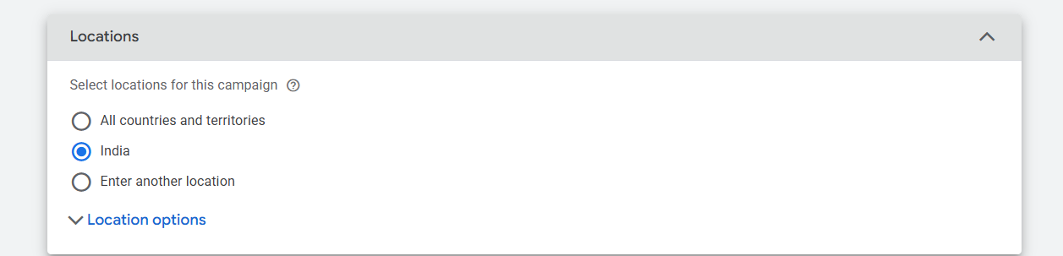
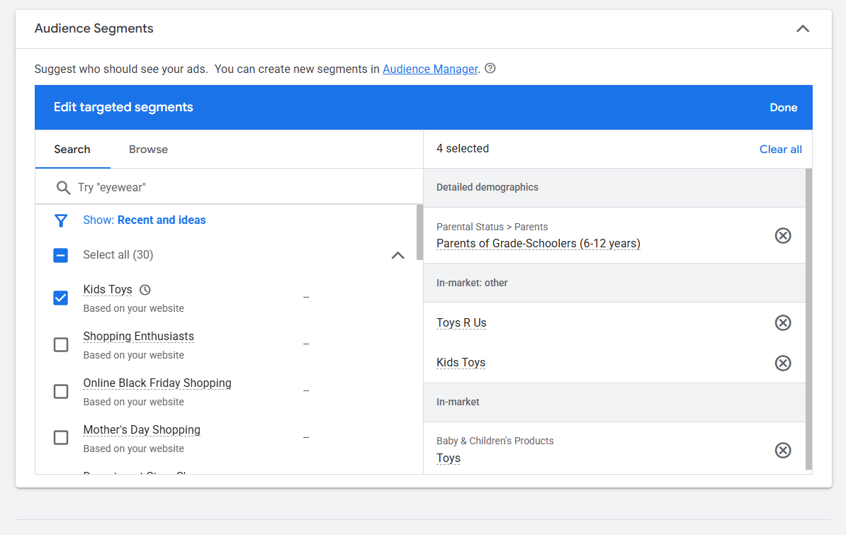
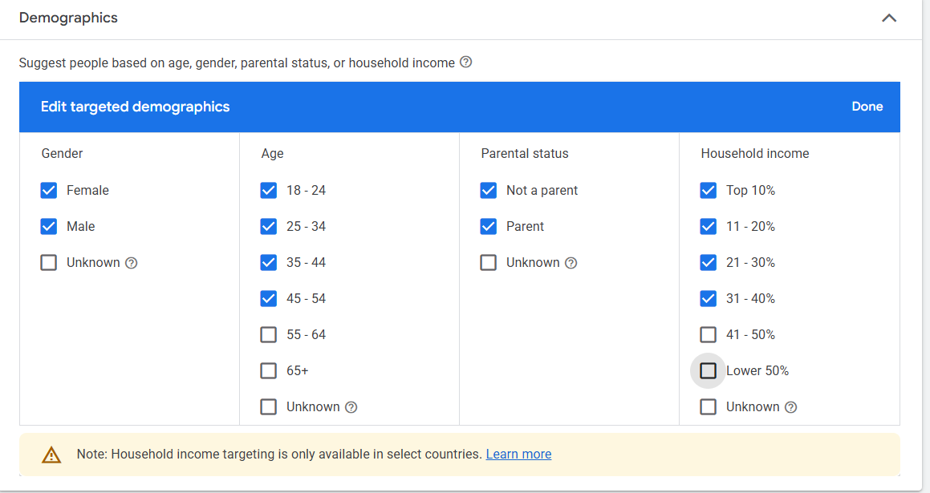
Screenshot of your Ad creative.
